
Application Architecture
Project XXXX
Client YYYY
<<Note: This document provides a generic template. It may require tailoring to suit a specific client and project situation.>>
Table of Contents
1 Application Principles 3
2 Application Portfolio Catalog for Current and Target States 4
3 Target System/Business Function Matrix and System/Data Matrix 5
4 List of Stakeholders and their Concerns 6
5 Current and Target Application Architecture 7
6 List of Application Gaps and Recommendations 8

Document Information
Project Name: | Project XXX
Prepared By: |  | Document Version No: | 0.1
Title: | Application Architecture | Document Version Date:
Reviewed By: |  | Review Date:
Distribution List
From | Date | Phone/Fax/Email

To | Action* | Due Date | Phone/Fax/Email
* Action Types: Approve, Review, Inform, File, Action Required, Attend Meeting, Other (please specify)
Document Version History
Version  Number | Version  Date | Revised By | Description | Filename

Application Principles
These principles of application architectures apply to all organizations within enterprise.
Business Principle | Enhance customer value
Name | Ease-of-use
Statement | Applications are easy to use. The underlying technology is transparent to users, so they can concentrate on tasks at hand.
Rationale | The more a user has to understand the underlying technology, the less productive that user is. Ease-of-use is a positive incentive for use of applications. It encourages users to work within the integrated information environment instead of developing isolated systems to accomplish the task outside of the enterprise's integrated information environment. Most of the knowledge required to operate one system will be similar to others. Training is kept to a minimum, and the risk of using a system improperly is low.
Implications | Applications will be required to have a common "look-and-feel" and support ergonomic requirements. Hence, the common look-and-feel standard must be designed and usability test criteria must be developed.  Guidelines for user interfaces should not be constrained by narrow assumptions about user location, language, systems training, or physical capability. Factors such as linguistics, customer physical infirmities (visual acuity, ability to use keyboard/mouse), and proficiency in the use of technology have broad ramifications in determining the ease-of-use of an application.

Application Portfolio Catalog for Current and Target States
Current application:
Application Name
Vessel Movement System (VMS)
Container Movement System (CMS)
Sales Order System (SOS)
Customer Billing System (CBS)
SGLine Website
Account and Financial Information System (AFIS)
Human Resource System (HRS)

System \ Function | Vessel Loading/Schedules Maintenance | Container Movement Timescales Maintenance | Sales Order Maintenance | Billing Maintenance | Distribute empty shipping containers by Prediction Engine or Manual Intervention | Track sales of empty containers | Track transfer of containers from SG’s vessels to 3rd party vessels | Marketing literature | Account and Financial Information | Human Resource Maintenance
Vessel Movement System (VMS) | X
Container Movement System (CMS) |  | X |  |  | X | X | X
Sales Order System (SOS) |  |  | X
Customer Billing System (CBS) |  |  |  | X
SGLine Website |  |  |  |  |  |  |  | X
Account and Financial Information System (AFIS) |  |  |  |  |  |  |  |  | X
Human Resource System (HRS) |  |  |  |  |  |  |  |  |  | X

Target application:
Application Name
Vessel and Container Movement System (VCMS)
Sales and Customer Billing System (SCBS)
Account and Financial Information System (AFIS)
Human Resource System (HRS)
Integrated Reporting System (IRS)
ShipTrack System (ST)

System \ Function | Vessel Loading/Schedules Maintenance | Container Movement Timescales Maintenance | Sales Order Maintenance | Billing Maintenance | Distribute empty shipping containers by Prediction Engine or Manual Intervention | Track sales of empty containers | Track transfer of containers from SG’s vessels to 3rd party vessels | Marketing literature | Account and Financial Information | Human Resource Maintenance | Reporting Function | Shipment Tracking Maintenance
Vessel and Container Movement System (VCMS) | X | X |  |  | X | X | X
Sales and Customer Billing System (SCBS) |  |  | X | X |  |  |  | X
Account and Financial Information System (AFIS) |  |  |  |  |  |  |  |  | X
Human Resource System (HRS) |  |  |  |  |  |  |  |  |  | X
Integrated Reporting System (IRS) |  |  |  |  |  |  |  |  |  |  | X
ShipTrack System (ST) |  |  |  |  |  |  |  |  |  |  |  | X
List of Stakeholders and their Concerns
Sales Order System does not have the original source code. Any functionality enhancement can’t be done.
VMS and CMS were based on old technology, which the resources to maintain the system takes too long.
Customers would like additional capabilities, such as direct RFQ, ordering, calculations of shipment time between destinations, etc.
Account and Financial Information System (AFIS) and the Human Resource System (HRS) provides adapter for MQ series and Java API, but these have never been used.

Current and Target Application Architecture

Current application architecture

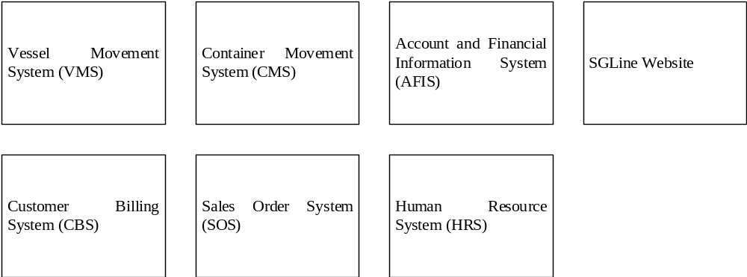
Each software application does not interoperate and interchange data. All data is manually input and retrieved by the team members.

Target application architecture
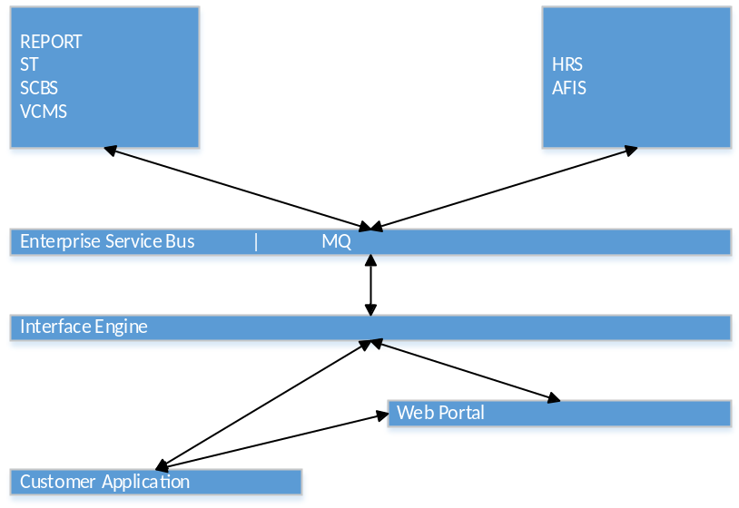
Enterprise Service Bus | MQ provides all communication between software applications in a service-oriented architecture (SOA).
The primary function of ESB:
- Monitor and control routing of message exchange between services
- Resolve contention between communicating service components
- Control deployment and versioning of services
- Marshal use of redundant services
- Cater for commodity services like event handling, data transformation and mapping, message and event queuing and sequencing, security or exception handling, protocol conversion and enforcing proper quality of communication service
All applications: REPORT, ST, SCBS, VCMS, HRS, AFIS can interact between application via ESB | MQ.
Interface Engine will provide required data interchange to the external application, e.g. Web Portal and Customer Application.

Interface Catalog
Vessel details
Container details
Shipment details
Quotation details / Order details / Billing details
Quotation submission / Order submission

List of Application Gaps and Recommendations

Account and Financial Information System (AFIS) is not interoperate with other application. AFIS can gather data from Sales Order System and Customer Billing System (CBS) to generate report for management.
Human Resource System (HRS) does not provide a way for employee to update their personal data (e.g. home address, phone number, etc) and make use single sign-in to use all applications inside the enterprise. The HRS can have function generate key performance indicator for employee based on the data on other applications.

